This Felix Cobbold. He will be the intermediator to show people a lens of the past. The app opens up with an avatar of him. He will introduce himself and talk more about what he does and who he is and any extra information he can provide. He is not a tour guide but more a person who can bridge the gap of time between visitor and exhibits to let them relate and engage with the rooms they enter. Creating empathy and bridging the gap of understanding, to make visitors have food for thought and enhance their imagination on their experience.

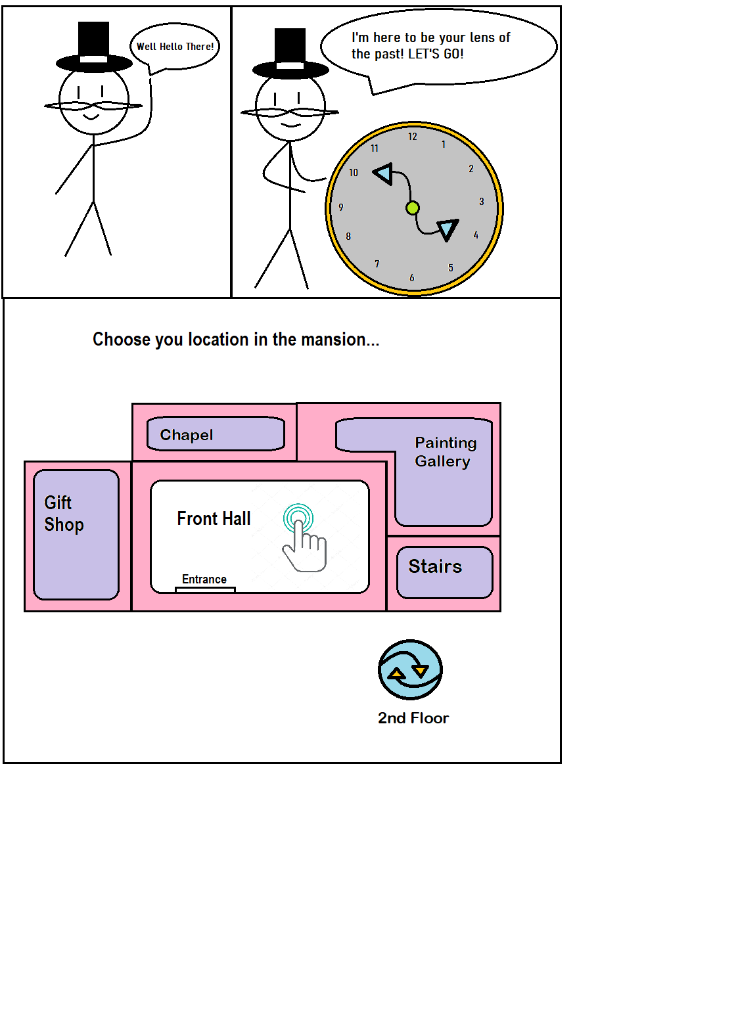

There are no rooms to be shown just yet. Making an example room to show in the pitch is still in progress.

Felix Cobbold will then ask the visitor to select the rooms they are in. Acting as an ice breaker for each room.   
  
When selecting a room, the visitors will be taken into a new scene where the focus is that room.   
  
Felix Cobbold will be the character to introduce the room and make visitors think about what they are seeing and how they can relate with it.

(We want the visitors to be more engaged with the room rather than the app, so it is balancing out the information we give to visitors along with how we ask them to engage and think over what they are seeing)